**HACKATHON 3 (DAY 2)**

**PLANNING THE TECHNICAL FOUNDATION**

The business-to-consumer aspect of electronic commerce (e-commerce) is the most visible business use of the World Wide Web. The primary goal of an e-commerce site is to sell goods and services online.

This project deals with developing an e-commerce website for Online Furniture Products. It provides the user with a catalog of different category of wooden furniture available for purchase in the store.

In order to facilitate online purchase a shopping cart is provided to the user. The system is implemented using a 3-tier approach, with a backend database (SANITY), a middle tier of Next.Js and React, and Tailwind CSS as the front end client. In order to develop an e-commerce website, a number of Technologies must be studied and understood. These include multi-tiered architecture, server and client side scripting techniques, implementation technologies such as JAVA, programming language (such as Typescript), databases (such as Sanity CMS). This is a project with the objective to develop a basic website where a consumer is provided with a shopping cart application and also to know about the technologies used to develop such an application. This document will discuss each of the underlying technologies to create and implement an e-commerce website

**INTRODUCTION**

E-commerce is fast gaining ground as an accepted and used business paradigm. More and more business houses are implementing web sites providing functionality for performing commercial transactions over the web. It is reasonable to say that the process of shopping on the web is becoming common place.

**PROJECT DESCRIPTION**

* An online store is a virtual store on the Internet where customers can browse the catalog and select products of interest.
* The selected items may be collected in a shopping cart. At checkout time, the items in the shopping cart will be presented as an order.
* At that time, more information will be needed to complete the transaction. Usually, the customer will be asked to fill or select a billing address, a shipping address, a shipping option, and payment information such as credit card number.
* An e-mail notification is sent to the customer as soon as the order is placed
* Only registered member can purchase multiple products regardless of quantity.
* They can view product details, add items to the card, as well as wish list and proceed.

**TO ACCESS PRODUCT**

* Any user access the marketplace and register and view available products.
* Only registered member can purchase multiple products regardless of quantity.
* They can view product details, add items to the card, as well as wish list and proceed.

**TO ORDER PRODUCT**

* Registered user can place an order.
* Registered user can place product in a wish list.
* Registered user can add product in Cart.
* Registered user confirm order from Cart.

**TO GATEWAY AND DELIVERY**

* Once payment is confirmed then order is shipped.
* User can track the status of shipment
* User has choose delivery option (cash on deliver, via Bank transaction)

**DESIGN AND DEVELOPMENT ENVIRONMENT**

* Node.Js & React for development
* Tailwind CSS for Frontend development
* Sanity CMS for Backend development
* Third party APIs for data fetch

**PROJECT DESIGN**

In order to design a web site, the database must be designed first. Conceptual design can be divided into two parts: The data model and the process model. The data model focuses on what data should be stored in the database while the process model deals with how the data is processed. To put this in the context of the database (**Schema**), the data model is used to design the **CMS**. The process model is used to design the queries that will access and perform operations on those tables.

**SYSTEM ARCHITECTURE**

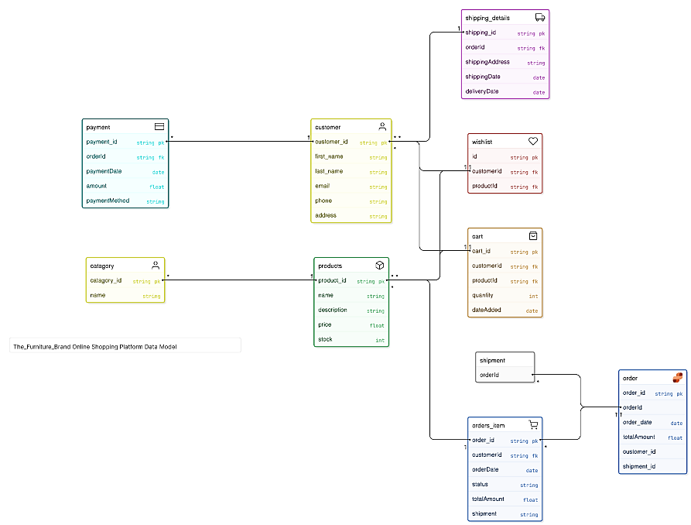

**DATABASE SCHEMA**

**The_Furniture_Brand** **Online** **Shopping** **Platform** **Data** **Model**[typeface: clean]

// define tables

**catagory** [icon: user, color: yellow] {

  catagory_id string **pk**

  name string

}

**customer** [icon: user, color: yellow] {

  customer_id string **pk**

  first_name string

  last_name string

  email string

  phone string

  address string

}

**products** [icon: box, color: green] {

  product_id string **pk**

  name string

  description string

  price float

  stock int

}

**wishlist** [icon: heart, color: red] {

  id string **pk**

  customerId string **fk**

  productId string **fk**

}

**orders_item** [icon: shopping-cart, color: blue] {

  order_id string **pk**

  customerId string **fk**

  orderDate date

  status string

  totalAmount float

  shipment string

}

**cart** [icon: shopping-bag, color: orange] {

  cart_id string **pk**

  customerId string **fk**

  productId string **fk**

  quantity int

  dateAdded date

}

**shipping_details** [icon: truck, color: purple] {

  shipping_id string **pk**

  orderId string **fk**

  shippingAddress string

  shippingDate date

  deliveryDate date

}

**payment** [icon: credit-card, color: teal] {

  payment_id string **pk**

  orderId string **fk**

  paymentDate date

  amount float

  paymentMethod string

}

**order** [icon: d365-intelligent-order-management, color : blue] {

  order_id string **pk**

  order_date date

  totalAmount float

  customer_id

  shipment_id

 }

// define relationships

**catagory**.catagory_id **>** **products**.product_id

**products**.product_id **>** **wishlist**.customerId

**products**.product_id **>** **orders_item**.order_id

**products**.product_id **>** **cart**.cart_id

**customer**.customer_id **>** **wishlist**.customerId

**orders_item**.order_id **>** **order**.orderId

**shipment**.orderId **>** **order**.orderId

**customer**.customer_id **>** **cart**.cart_id

**payment**.payment_id **>** **customer**.customer_id

**customer**.customer_id  **>** **shipping_details**.shipping_id

**DEFINE API ENDPOINTS**

**GET**

The GET method is used to retrieve resources from a server. It is said to be a safe method as it does not change the state of the resource in any way.

GET method is idempotent Thus calling this method multiple times will always give the same result.

**POST**

POST method is used to create a new resource into the collection of resources on a server.

**PUT**

PUT is used to update the existing resource on the server and it updates the full resource.

If the resource does not exist, PUT may decide to create a new resource.

PUT method is idempotent Thus calling this method multiple times will always update the same resource multiple times.

**PATCH**

PATCH is used to update the existing resource on the server and it updates a portion of the resource.

If the resource does not exist, PUT may decide to create a new resource.

Just as the PUT method, PATCH is also idempotent

**CONCLUSION**

The Internet has become a major resource in modern business, thus electronic shopping has gained significance not only from the entrepreneur’s but also from the customer’s point of view. For the entrepreneur, electronic shopping generates new business opportunities and for the customer, it makes comparative shopping possible. As per a survey, most consumers of online stores are impulsive and usually make a decision to stay on a site within the first few seconds